Web-Based Event Management System with Community Forum for City Mayor's Office Muslim Concerns and Affairs Division

A Capstone Project Proposal
Presented to the Faculty of the
Information and Communications Technology Program
STI College - General Santos, Inc.

In Partial Fulfilment
of the Requirements for the Degree
Bachelor of Science in Information Technology

Ashley Jan M. Aso
John Carlos Kozel A. Carcillar
Neil Amos C. Cloa
Josh Angelu Seanville L. Reyes

April 22, 2026

ENDORSEMENT FORM FOR PROPOSAL DEFENSE

TITLE OF RESEARCH: Web-Based Event Management System with Community Forum For City Mayor's Office Muslim Concerns and Affairs Division.
NAME OF PROPONENTS: Ashley Jan Aso
John Carlos Kozel A. Carcillar
Neil Amos C. Cloa
Josh Angelu Seanville L. Reyes

In Partial Fulfilment of the Requirements
for the Bachelor of Science degree in Information Technology
has been examined and is recommended for Proposal Defense.

ENDORSED BY:

Benhar L. Masahod, LPT
Capstone Project Adviser

APPROVED FOR PROPOSAL DEFENSE:

Jolina Migrino, LPT
Capstone Project Coordinator

Jhon Dell B. Aristales
Capstone Project Coordinator

NOTED BY:

Anthony Mark Silong, MIT
Program Head

APRIL 22, 2026

APPROVAL SHEET

This capstone project proposal titled Web-Based Event Management System with Community Forum For City Mayor's Office Muslim Concerns and Affairs Division prepared and submitted by Ashley Jan Aso, John Carlos Kozel A. Carcillar, Neil Amos Cloa, and Josh Angelu Seanville Reyes, in partial fulfillment of the requirements for the degree of Bachelor of Science in Information Technology, has been examined and is recommended for acceptance and approval.
Benhar L. Masahod, LPT
Capstone Project Adviser

Accepted and approved by the Capstone Project Review Panel
in partial fulfillment of the requirements for the degree of
Bachelor of Science in Information Technology

Nur Ali Padasan, MIT, LPT
Panel Member
Dan Henly P. Sales
Panel Member

Anthony Mark F. Silong, MIT
Lead Panelist

Noted:

Jolina M. Migrino, LPT
Capstone Project Coordinator
Anthony Mark F. Silong, MIT
Program Head

April 22, 2026

TABLE OF CONTENTS

Page
Title Page i
Endorsement Form for Proposal Defense ii
Approval Sheet iv
Table of Contents v
Introduction 1
Project Context 1
Purpose and Description 2
Objectives 3
Scope and Limitations 4
Review of Related Literature/Studies/Systems 7
Methodology 12
Technical Background 16
Requirements Analysis 17
Requirements Documentation 19
Design of Software, System, Product, and/or Processes 24
References 30
Appendices 33
Appendix A. Figures 34
Appendix B. Tables/Notation 38
Appendix C. Personal Technical Vitae 40
Resource Persons 41

INTRODUCTION

Project Context

The Muslim community in General Santos City, like many across the Philippines, observes Ramadan as the most sacred season of the year. It is marked by fasting, prayer, charity, and community gatherings. Ramadan involves a wide range of organized programs at the barangay and mosque levels, including Iftar events, Taraweeh prayer schedules, charitable distributions, community announcements, and coordination with local government officials. According to the National Commission on Muslim Filipinos (NCMF, 2022), Muslim communities in Mindanao continue to grow in number and organizational complexity, reinforcing the need for structured coordination mechanisms during major Islamic observances.
Despite the increasing number of Ramadan-related activities, many barangays and Muslim community organizations in General Santos City still rely on manual and informal processes to manage these programs. Common tools include paper-based scheduling, social media postings, messaging applications, and verbal announcements. While these methods provide basic coordination, they often result in schedule conflicts, delayed announcements, incomplete monitoring, and difficulties in tracking donations and resource distributions. The absence of a centralized platform limits the efficient management of time-sensitive programs involving multiple stakeholders such as barangay officials, Imams, community leaders, and residents.
Globally, the adoption of web-based systems for community and event management has been shown to reduce manual workload and improve coordination. Garcia and Santos (2021) stated that interactive web-based systems enhance stakeholder engagement by enabling active participation in planning and service delivery. In the Philippine context, the Department of Trade and Industry (DTI, 2022) highlighted the increasing adoption of digital platforms among government and community organizations to streamline operations.
Findings from the data gathering further confirm that current practices rely on messaging applications, paper-based invitations, and social media postings for scheduling and announcements. Attendance is recorded manually, while donation and distribution records are also managed through manual or informal methods. These practices lead to challenges such as difficulty in confirming participant attendance, inefficiencies in coordination, and limited accessibility for elderly participants and those in remote areas. These findings emphasize the need for a centralized web-based system to improve organization, communication, and documentation of Ramadan community programs.

Purpose and Description

The purpose of the proposed system is to provide a centralized and structured digital platform that improves the management, coordination, and documentation of Ramadan-related community activities. The system is designed to enhance collaboration among LGU/Barangay Admins, Imams/Mosque Administrators, Community Leaders, and Community Viewers by integrating scheduling, notification, monitoring, and reporting functionalities into a single web-based application. It aims to reduce reliance on manual processes, improve information accuracy, and streamline communication among stakeholders.
The system enables authorized users to create and manage event schedules, including assigned venues, organizers, and time details, with a calendar view for better visualization. It includes an announcement and notification module for posting updates and sending alerts to stakeholders. Community leaders and Imams can input prayer schedules, mosque events, and charitable activities for centralized documentation.
Additionally, the system provides activity monitoring and attendance tracking features to record participation and track event status. A resource and donation management module supports the recording of donations and distributions, ensuring transparency. The system also generates printable reports, including event schedules, attendance summaries, and donation records.
Overall, the system enhances service delivery by improving organization, communication, and transparency. By utilizing web-based technologies accessible through internet-connected devices, the system promotes accessibility and efficiency, leading to improved coordination and community engagement during the Ramadan season.

Objectives

General Objective

To design and develop Web-Based Event Management System with Community Forum For City Mayor's Office Muslim Concerns and Affairs Division., a web-based scheduling, notification, and activity monitoring system that will improve the coordination, communication, and documentation of Ramadan season programs and community services in General Santos City.

Specific Objectives

- Develop a web-based event management system with role-based access for LGU/Barangay Admin, Imam/Mosque Administrator, Community Leader, and Community Viewer, ensuring secure and centralized management of Ramadan programs.
- Design and implement an integrated scheduling, announcement, and notification module that supports efficient event planning, real-time information dissemination, and coordinated communication among stakeholders.
- Develop an activity monitoring, attendance tracking, and resource management module that records event participation, tracks event status, and documents donations and distributions for transparent program management.
- Generate automated, printable, and exportable reports, including event schedules, attendance summaries, and donation records, to support evaluation and decision-making by barangay officials.

Scope and Limitations

The scope of the project covers the development of Web-Based Event Management System with Community Forum For City Mayor's Office Muslim Concerns and Affairs Division. The system is designed to improve program scheduling, announcement dissemination, activity monitoring, and donation tracking for Ramadan-related community programs. The System aims to enhance coordination, communication, and transparency among its four primary users: LGU/Barangay Admin, Imam/Mosque Administrator, Community Leader, and Community Viewer. By integrating these modules into a single centralized platform, the system minimizes reliance on manual and informal tools, improves data organization, and ensures a more efficient workflow for Ramadan program management.

The following were the scopes of the project:

User Management Module
The system supports four user roles with role-based access control:
  - LGU/Barangay Admin – manages the entire system, approves accounts, and generates reports.
  - Imam/Mosque Administrator – inputs prayer schedules and mosque-related events.
  - Community Leader – submits and monitors community Ramadan activities.
  - Community Viewer – views published announcements and schedules.

Ramadan Program and Activity Scheduling Module
  - Create, edit, and delete Ramadan events such as Iftar programs, Taraweeh schedules, and charity drives.
  - Assign event details including title, date and time, venue, organizer, and description.
  - Calendar view and list view for event schedules.
  - Event status tracking categorized as upcoming, ongoing, or completed.

Announcement and Notification Module
  - Post official announcements categorized as prayer schedules, event reminders, charity drive updates, or community advisories.
  - System notification alerts for registered users.
  - Optional email notification feature for stakeholder dissemination.

Activity Monitoring and Attendance Tracking Module
  - Attendance list input per event.
  - Event monitoring dashboard showing event status and participation statistics.
  - Generate simple event monitoring reports.

Resource and Donation Management Module
  - Record donations received including donor name (optional), donation type (cash, food, or supplies), amount or quantity, and date received.
  - Record distribution logs including beneficiary, items distributed, and date.
  - Donation and distribution summary dashboard.

Report Generation Module
  - Generate and export printable reports including Ramadan event schedule reports, attendance summaries, and donation and distribution records.
  - Export options via PDF or browser print function.

Dashboard and Analytics
  - Summary dashboard showing total number of events, upcoming events, attendance totals, and donation totals.

The limitations of the study are as follows:
- System Access Limitation: Web-Based Event Management System with Community Forum for City Mayor's Office Muslim Concerns and Affairs Division. is a web-based application and requires a stable internet connection and a compatible web browser. Offline functionality is not supported.
- Mobile Application Limitation: The system is web-only and mobile-responsive but does not include a dedicated Android or iOS mobile application.
- Notification Limitation: Real-time SMS gateway integration is not included unless a free API is available during development. Notifications are limited to in-system alerts and optional email notifications.
- Attendance Tracking Limitation: Biometric attendance tracking and QR code scanning are not included in the base scope and are considered optional features subject to time availability.
- Islamic Calendar Limitation: Automated Islamic calendar computation is not included. All event dates and schedules are entered manually by the authorized administrator.
- Payment Processing Limitation: The system does not support online payment processing for donations. All donation records are manually entered by authorized users.
- Data Accuracy Limitation: The accuracy of event schedules, attendance records, and donation logs is dependent on correct and timely input from authorized users. Incorrect data entry may affect the reliability of generated reports.

Review of Related Literature/Studies/Systems

In today's digital environment, community-based organizations and local government units increasingly rely on web-based systems to automate operations, improve service coordination, and enhance stakeholder engagement. The transition from manual processes to digital platforms has been shown to significantly reduce operational delays and improve accuracy in program management. Community programs, particularly those tied to cultural and religious observances, require structured and timely coordination that informal tools such as chat applications and paper-based records cannot reliably provide.
Sukmandhani et al. (2022) developed a dashboard-based web application for service management operations that integrates report accommodation and task administration into a centralized platform, achieving an 84% user acceptance rate and streamlining business and service management processes. This supports the feasibility of a centralized web-based approach for community program management such as that proposed by Web-Based Event Management System with Community Forum For City Mayor's Office Muslim Concerns and Affairs Division.
Similarly, Kukartsev et al. (2023) demonstrated that automated information systems can optimize management by automating requests, monitoring quality, and generating operational reports. These principles are directly applicable to the scheduling and monitoring requirements of Ramadan community programs where accuracy and timeliness are critical.

Regarding scheduling and notification systems, web-based platforms have proven effective in improving the dissemination of timely information to stakeholders. Alhambra and Parcero (2020) demonstrated that an online appointment and notification system implemented in a healthcare setting significantly reduced delays in information delivery and improved coordination among staff and clients. The study highlights that centralized scheduling systems can be adapted across different sectors, including community-based program management.
Ampuan and Delena (2023) further developed a web-based appointment and notification system for university offices in the Philippines, finding that automated notification features reduced missed appointments and improved user satisfaction. These findings support the inclusion of a notification module in Web-Based Event Management System with Community Forum For City Mayor's Office Muslim Concerns and Affairs Division to ensure timely dissemination of Ramadan program updates to community members and barangay stakeholders.
In the context of activity monitoring and attendance tracking, web-based monitoring systems have demonstrated their capacity to support transparent and accountable program documentation. Frevizola and Irfan (2025) developed a web-based work progress monitoring system that is accessible across various devices, supports efficient data updates, and enhances coordination among technical disciplines within the project. Their findings confirm the effectiveness of web-based monitoring in tracking event participation and program status.
Shree (2025) proposed an advanced real-time monitoring dashboard that incorporates role- based access control and streamlined data visualization, enhancing collaboration among teams and minimizing manual errors. These features are consistent with the activity monitoring and attendance tracking module proposed for Web-Based Event Management System with Community Forum For City Mayor's Office Muslim Concerns and Affairs Division.
For resource and donation management, transparent and accountable record-keeping is essential for community trust and program sustainability. Cabubas et al. (2025) developed a Customer Feedback Management System that integrates multi-channel data collection and real-time analysis dashboards, significantly enhancing processing efficiency and data-driven
decision-making. The data management principles applied in their study are applicable to the donation and distribution tracking objectives of Web-Based Event Management System with Community Forum For City Mayor's Office Muslim Concerns and Affairs Division.

Praise et al. (2024) found that effective use of documented records enables organizations to identify service gaps and improve operational efficiency. In the context of Ramadan resource management, systematic documentation of donations and distributions can support barangay officials in evaluating program impact and planning future charitable activities.

Role-Based Access Control (RBAC) is widely used in web-based systems to ensure secure and organized access to system functionalities. Samonte et al. (2024) emphasized the necessity for tailored RBAC models that streamline access control by aligning privileges with organizational responsibilities, recommending hierarchical structures that reflect real-world organizational roles. This is directly relevant to Web-Based Event Management System with Community Forum For City Mayor's Office Muslim Concerns and Affairs Division.s multi-role user structure involving administrators, Imams, community leaders, and community viewers.

Manoj et al. (2025) further confirmed that implementing RBAC with secure authentication significantly reduces insider threats and supports regulatory compliance. Their findings reinforce the importance of controlled access and role-based permissions in Web-Based Event Management System with Community Forum For City Mayor's Office Muslim Concerns and Affairs Division.particularly given the sensitive nature of community donation records and event documentation.

Regarding report generation, the ability to produce printable and exportable summaries from system data is a critical feature for community and barangay program evaluation. Abraham et al. (2025) developed a web application that uses real-time data and project parameters to generate accurate summary reports, with responsive design and structured data storage ensuring accessibility. Their approach supports the feasibility of including printable report generation in Web-Based Event Management System with Community Forum For City Mayor's Office Muslim Concerns and Affairs Division.
Rehiara et al. (2025) also demonstrated that web-based reporting platforms significantly reduce processing time, improve calculation accuracy, and simplify documentation revisions compared to traditional manual methods. These findings directly support the report generation module proposed for Web-Based Event Management System with Community Forum For City Mayor's Office Muslim Concerns and Affairs Division., which aims to replace manual report preparation with automated, print-ready outputs.
In terms of system usability and evaluation, Wilson and Price (2024) emphasized that responsive web design and accessibility-first development improve overall user experience and ensure wider audience reach, particularly for users accessing systems on mobile devices. This is consistent with Web-Based Event Management System with Community Forum For City Mayor's Office Muslim Concerns and Affairs Division. design requirement for a mobile-responsive, browser-accessible interface that does not require software installation.
Existing systems demonstrate the capabilities of web-based platforms in managing community activities but also reveal important limitations. Many current platforms focus on either scheduling or notification or monitoring in isolation, without integrating these functions into a unified system. Additionally, most existing systems are designed for general administrative or commercial use and do not address the specific cultural and religious coordination requirements of Ramadan community programs. These limitations highlight the need for a purpose-built, integrated system that combines scheduling, notification, monitoring, and donation tracking in a single accessible platform. The reviewed literature confirms that web- based systems can significantly improve coordination, transparency, and documentation, and there is a clear gap in the development of a unified platform tailored for Ramadan community program management. Web-Based Event Management System with Community Forum For City Mayor's Office Muslim Concerns and Affairs Division. aims to address this gap by providing a comprehensive, culturally relevant, and accessible digital solution for barangays and Muslim community organizations in General Santos City.

METHODOLOGY

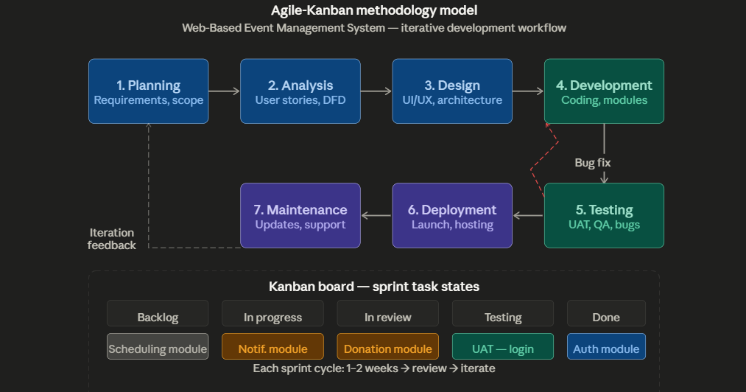
Figure 1: Agile-Kanban Methodology Mode

The methodology used in developing the proposed system focuses on creating a user-centered, efficient, and scalable web application. The system is designed to improve scheduling, announcement dissemination, activity monitoring, and donation tracking for Ramadan community programs in General Santos City.

To achieve this, the researchers adopted the Agile Kanban methodology, which supports continuous development, flexibility, and adaptation to changing user requirements. This approach allows the team to develop the system in manageable tasks while continuously testing and improving each feature. Key components such as event scheduling, notification management, attendance tracking, and donation recording were developed iteratively to ensure functionality, usability, and reliability.

The development process began with a planning phase, where functional and non-functional requirements were identified through interviews and consultations with barangay staff, Imams, and community leaders. Functional requirements included event management, announcement posting, attendance tracking, donation recording, and report generation, while non-functional requirements focused on usability, performance, and security.
A Kanban board was used to manage tasks, categorized into “To Do,” “In Progress,” and “Done,” allowing the team to monitor progress and address issues efficiently. Continuous testing and user feedback were incorporated throughout development to ensure that the system meets user needs and operates effectively.

Agile Kanban was chosen for this project because it provides a visual, flexible, and efficient framework for managing software development. The system was developed in stages across the four main user modules — Barangay Admin, Imam, Community Leader, and Community Viewer — while continuously integrating feedback into the workflow. The use of a Kanban board enabled the team to track tasks, monitor progress, and manage priorities effectively, ensuring that development stayed aligned with project objectives and timelines. Through this approach, the system remained iterative and adaptable, allowing continuous improvement of features such as event scheduling, notification delivery, activity monitoring, and report generation.
The development process began with a comprehensive planning phase, where the researchers identified and analyzed both functional and non-functional requirements of the system through interviews and consultations with barangay staff, Imams, and community leaders. Functional requirements included event creation and management, announcement posting, attendance recording, donation logging, and report generation, while non-functional requirements focused on usability, system performance, and data security. These requirements were translated into detailed user stories that reflected the needs of all user roles. Each user story was then divided into smaller, actionable tasks to ensure clarity and efficient implementation.
Following the planning stage, a Kanban board was established as the main tool for visualizing the development workflow. The board was organized into columns such as To Do, In Progress, and Done, with each task represented by a card that moved across these stages as work progressed. This setup allowed the team to clearly monitor task status, track overall development progress, and quickly identify delays or bottlenecks. It also improved transparency and accountability, as all team members had real-time visibility of the project workflow.
During the execution phase, the team adopted a pull-based approach by selecting tasks from the To Do column based on priority and team capacity. Developers worked collaboratively to implement system features, including the Admin module for system and user management, the scheduling and notification modules for event coordination, and the monitoring and donation modules for activity tracking and resource documentation. Continuous integration and testing were conducted to ensure that each feature functioned correctly and met the defined acceptance criteria.
After completing development tasks, the system underwent testing and evaluation to validate its functionality, performance, and usability. The researchers simulated real-world Ramadan program management scenarios by acting as Barangay Admins, Imams, and Community Leaders to test the system's full workflow. Admins tested user management, event scheduling, announcement posting, and report generation. Community leaders tested attendance recording and donation entry, while Imams tested prayer schedule input and event monitoring. Tasks that passed testing were marked as completed and moved to the Done column.
User feedback was gathered through system demonstrations and evaluations, which played a crucial role in refining the platform. Barangay staff found the centralized scheduling and notification features helpful in improving coordination. Community leaders appreciated the donation tracking and report generation capabilities, while Imams valued the organized schedule management for prayer times and mosque events. Suggestions for improvement were incorporated into subsequent development cycles through the updated product backlog.
Finally, the team engaged in continuous improvement through regular evaluation and retrospective activities to identify strengths, weaknesses, and possible enhancements. The product backlog was continuously updated to incorporate new features, improvements, and user feedback, ensuring that the system remained relevant, efficient, and user-friendly throughout the development process.

Technical Background

Technologies to be Used

Web-Based Event Management System with Community Forum For City Mayor's Office Muslim Concerns and Affairs Division was developed using standard and widely adopted web technologies to ensure accessibility, reliability, and ease of deployment. The frontend of the system was created using HTML, CSS, and JavaScript, which are essential technologies for building interactive and responsive web applications. HTML was used to structure the web pages, CSS was applied to design and enhance the visual presentation, and JavaScript was utilized to implement dynamic features and improve user interaction. The development environment used was Visual Studio Code (VS Code), which provided a flexible and efficient platform for coding, debugging, and managing project files.

On the back-end, the system was developed using PHP, a server-side scripting language that enables the processing of user requests, handling of business logic, and communication with the database. PHP was used to manage core system functionalities such as user authentication, event scheduling logic, announcement posting, attendance recording, donation entry management, and report generation. This allowed the system to dynamically generate content and respond to user actions in real time.
For data storage and management, the system utilized MySQL, a relational database management system known for its reliability and efficiency. MySQL was used to store and organize important system data including user accounts, event schedules, attendance records, donation logs, distribution records, and announcement content. The integration of PHP and MySQL enabled efficient data retrieval, updating, and management, ensuring data consistency and system reliability throughout the Ramadan program period.
The system also incorporates responsive web design principles to ensure accessibility across desktop and mobile devices, which is particularly important for community users who primarily access digital platforms through smartphones. Each user role was provided with a role-based dashboard designed to support their specific tasks, such as system management for the Barangay Admin, event input for the Imam, activity coordination for the Community Leader, and announcement viewing for the Community Viewer.
Overall, the combination of HTML, CSS, JavaScript, PHP, and MySQL provides a stable, cost-effective, and scalable solution for developing the proposed web-based system. This technology stack supports efficient system performance, secure data handling, and a user- friendly interface, ensuring that the platform effectively meets the needs of all user roles during the Ramadan season.

Calendar of Activities

The Calendar of Activities outlines the schedule of tasks involved in the development of the Web-Based Event Management System with Community Forum for City Mayor's Office Muslim Concerns and Affairs Division. It serves as a timeline that guides the project’s progression, ensuring that each phase, from planning to deployment, is executed in an organized and timely manner.

Gantt chart of Activities
The Gantt chart presents the summary of activities. Listed are the activities and opposite them are their duration or periods of execution.
Legend:
Ongoing
Completed

MONTH | JANUARY |  |  |  | FEBRUARY |  |  |  | MARCH |  |  |  | APRIL |  |  |  | MAY |  |  |  | JUNE |  |  |  | JULY |  |  |  | AUGUST |  |  |  | SEPTEMBER |  |  |  | OCTOBER
ACTIVITY | 1 | 2 | 3 | 4 | 1 | 2 | 3 | 4 | 1 | 2 | 3 | 4 | 1 | 2 | 3 | 4 | 1 | 2 | 3 | 4 | 1 | 2 | 3 | 4 | 1 | 2 | 3 | 4 | 1 | 2 | 3 | 4 | 1 | 2 | 3 | 4 | 1 | 2 | 3 | 4
Course Orientation for Capstone 1
Formation of Group
Capstone Title Defense
Title Approval
Selection of Capstone Advisers
Sprint Planning & Backlog Creation
Chapter I: Introduction
User Research & Wireframing
Chapter II: RRL and RRS
Interface & Prototype Design
Chapter III: Methodology
System Development (Frontend and Backend
Capstone Project 1 Mock Defense
Revision of Documentation
Capstone Project 1 Re-Mock Defense
Capstone Project 1 Final Defense
Capstone 1 Final Revisions
Web and Mobile Application Development
Capstone Project 2 Mock Defense
Beta Testing
Capstone Project 2 Final Mock Defense
Capstone 2 Final Defense
Table 1. Gantt Chart

System Requirements

The table below presents the minimum software and hardware requirements necessary for the development and deployment of Web-Based Event Management System with Community Forum for City Mayor's Office Muslim Concerns and Affairs Division.
Category | Requirements
Operating System | Windows
Web Browser | Google Chrome, Microsoft Edge
Frontend Technology | HTML, CSS, JavaScript
Backend Technology | PHP
Database | MySQL
Development Tools | Visual Studio Code
Notification Integration | Email-based (PHPMailer or similar)
Table 2. Software Requirements

Category | Requirements
Processor | Intel Core i3 or higher
RAM | Minimum 4 GB
Storage | At least 256 GB HDD/SSD
Display | Monitor with at least 1366x768 resolution
Network | Stable internet connection
Input Devices | Keyboard and Mouse

Deployment | Cloud-based or local server
Table 3. Hardware Requirements
Requirements
In the initial phase of system development, comprehensive planning, data gathering, and analysis were conducted to determine the system requirements and prepare formal documentation. This phase serves as the foundation of the Software Development Life Cycle (SDLC), ensuring that the proposed system effectively addresses user needs and operational challenges.
Requirements Analysis
The requirements analysis was conducted through interviews and consultations with key stakeholders, including barangay personnel, Imams, and community leaders. Findings revealed that event scheduling, coordination, and communication are currently managed through informal and manual methods such as messaging applications, social media, and paper-based records.
Attendance tracking and reporting are performed manually, while donation and distribution records lack standardization and centralization. Respondents also identified several challenges, including difficulty in confirming attendance, inefficient coordination, limited data accessibility, and usability concerns for elderly users and individuals in remote areas. These findings highlight the need for a centralized, web-based system that enhances accessibility, improves communication, supports attendance confirmation, and ensures efficient and organized documentation of community activities.

WHO: The People Involved
- LGU/Barangay Administrator
Responsible for overall system management, including user account administration, event scheduling approval, announcement posting, and report generation.
- Imam / Mosque Administrator
Manages prayer schedul es and mosque-related activities, and validates religious announcements to ensure accuracy and alignment with community practices.
- Community Leader / Organizer
Organizes and submits community activities, records attendance, manages donation and distribution entries, and monitors activity status.
- Community Viewer (Residents)
Accesses event schedules, announcements, and updates. This role is limited to viewing information without modification privileges.
WHAT: The Business Activity
The system is designed to streamline the management of Ramadan community programs through a centralized digital platform. It replaces manual and fragmented processes with an integrated solution that supports:
- Online event scheduling and management
- Announcement dissemination and notifications
- Attendance tracking and monitoring
- Donation and distribution recording
- Report generation and data management
WHERE: The Environment
The system operates in both development and production environments:
- Development Environment:
Developed using Visual Studio Code and tested locally through XAMPP (Apache, PHP, MySQL).
- Production Environment:
Deployed on a web hosting platform, ensuring system availability,security, and accessibility via internet-enabled devices. Users can access the system through standard web browsers, ensuring cross-device compatibility and responsive design.
WHEN: The Timing
- User Access: The system is available 24/7, allowing users to access schedules, announcements, and reports anytime.
- Administrative Access: Administrators and authorized users manage system operations during working hours or as needed.
- System Processes: Notifications, updates, and data recording occur in real time or immediately after user actions.
Functional Requirements
The system shall provide the following functionalities:
1. User Management
The system shall allow Barangay Admin to create, update, activate, suspend, and manage user accounts. The system shall enforce secure authentication and role-based access control.
2. Event Scheduling
The system shall allow authorized users to create, edit, and manage event schedules. The system shall display events in both calendar and list views. The system shall categorize events as upcoming, ongoing, or completed.
3. Announcement and Notification
The system shall allow administrators to post announcements.
The system shall notify users through in-system alerts and optional email notifications.
4. Attendance Tracking and Monitoring
The system shall allow authorized users to record attendance per event. The system shall generate participation summaries and monitoring logs.
5. Donation and Distribution Management
The system shall allow recording of donation and distribution details. The system should provide summarized and organized donation records.
6. Report Generation
The system shall generate printable and exportable reports (e.g., PDF format).
7. Dashboard
The system shall display summarized data on events, attendance, and donations for quick monitoring and decision-making.
Requirements Documentation
This section presents the detailed requirements of the proposed system, defining its features, scope, and expected functionalities. It serves as a guide for system design and development, ensuring alignment between stakeholder needs and system capabilities.
The documentation establishes a clear understanding among stakeholders, minimizes miscommunication, and supports efficient project implementation. It also ensures that the system maintains quality, usability, and performance standards throughout the development process.
Design of Software, System, Product, and/or Processes
The system design outlines the overall structure, architecture, and workflow of the platform. It includes the development of data models, process flows, and interface designs to ensure efficient system functionality.
Core processes such as event scheduling, announcement dissemination, attendance tracking, donation management, and report generation are structured to ensure seamless interaction between system components. The design also incorporates appropriate technologies and frameworks to support system performance, scalability, and security.

Context Flow Diagram (CFD)

The Context Flow Diagram illustrates the interaction between the system and its four external users: LGU/Barangay Admin, Imam/Mosque Administrator, Community Leader, and Community Viewer. Each user provides specific inputs such as event details, announcements, attendance records, and donation data, while the system processes and returns outputs including schedules, notifications, reports, and updates. This diagram highlights the overall flow of information and the system’s role in centralizing Ramadan program management.

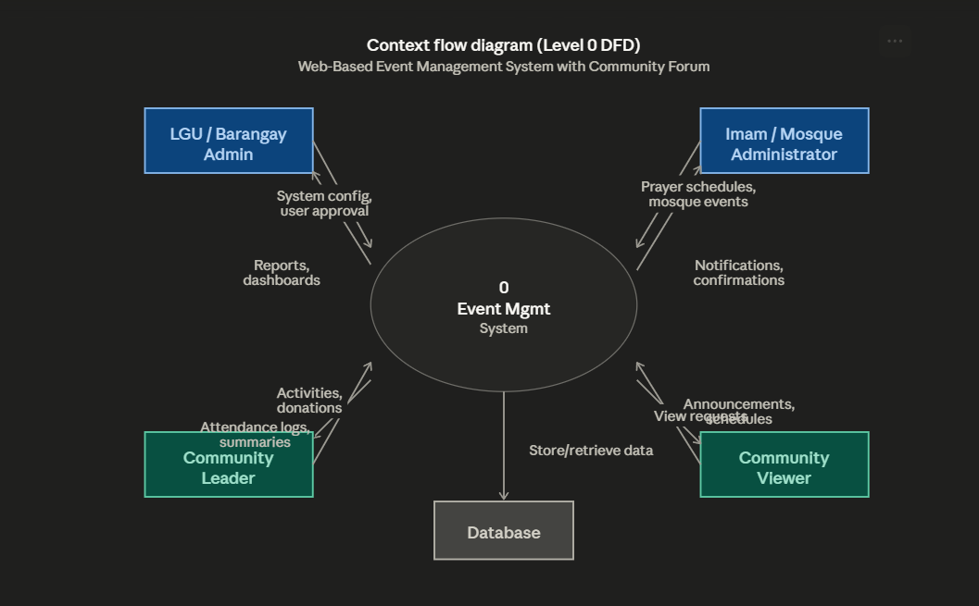 Figure 2. Context Flow Diagram

Level 1 Data Flow Diagram (DFD)

The Level 1 Data Flow Diagram presents the major system processes, including user management, event scheduling, announcement and notification handling, activity monitoring, donation recording, and report generation. It illustrates how data flows between users and system databases, ensuring efficient processing, storage, and retrieval of information necessary for coordinated program management.

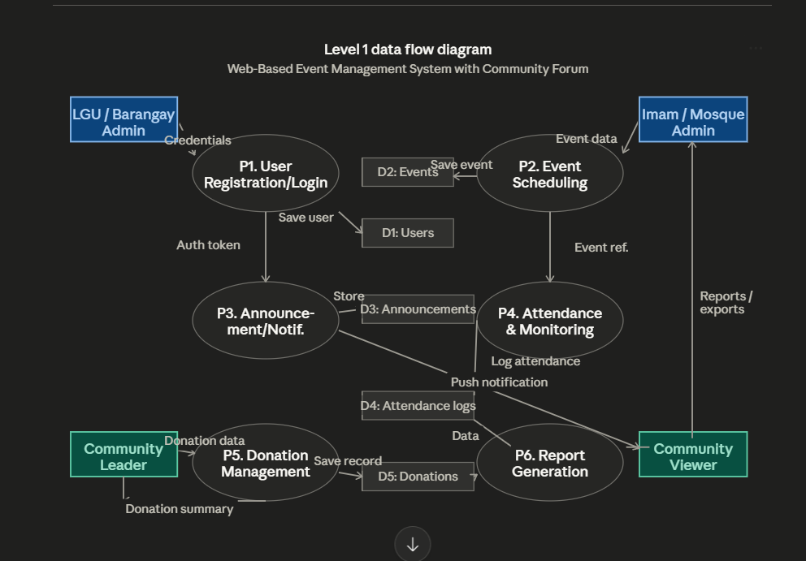
Figure 3. Level 1 Data Flow Diagram

Use Case Diagram

The Use Case Diagram represents the interactions between system users and the core functionalities of the system. Each user role—LGU/Barangay Admin, Imam/Mosque Administrator, Community Leader, and Community Viewer—performs specific actions such as managing schedules, posting announcements, recording attendance, and viewing program information. The diagram highlights the system’s role in supporting organized, role-based operations.

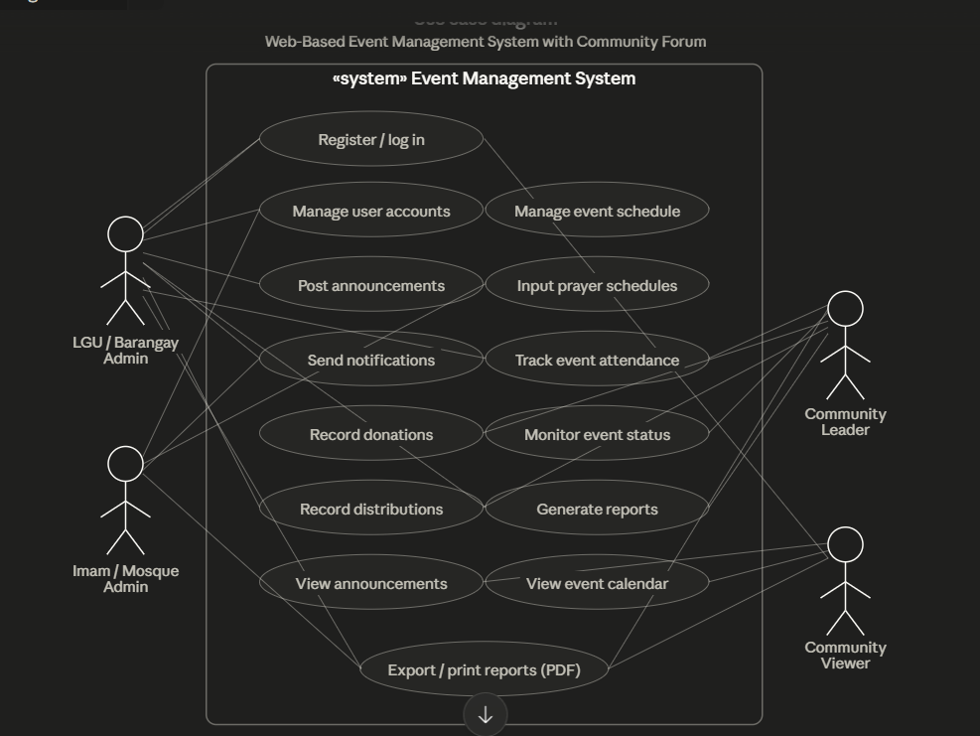
Figure 4. Use Case Diagram

Flowchart

The flowchart illustrates the process of managing a Ramadan community activity within the system. It begins with user authentication, followed by event creation and submission by an authorized user. The LGU/Barangay Admin reviews and approves the event, after which it becomes visible to all users. Notifications are then disseminated through the system.

During the event, attendance is recorded and the event status is updated accordingly. After completion, donation and distribution data are logged, and the system generates a summary report. This process demonstrates the end-to-end workflow from event creation to documentation.

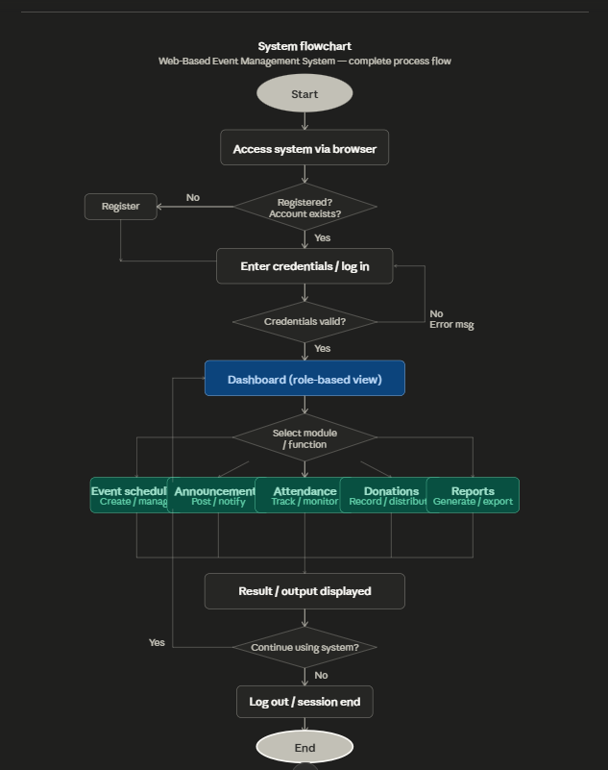

Figure 5. Flowchart

The flowchart illustrates the step-by-step process of how a Ramadan community activity is created, managed, and documented through the Web-Based Event Management System with Community Forum For City Mayor's Office Muslim Concerns and Affairs Division. system. The process begins when an authorized user logs in and creates a new event or activity with complete schedule details. The Barangay Admin reviews and approves the submitted event, after which it is published and visible to all users. Community members are notified of the new event through the system's announcement and notification module. As the event progresses, authorized users record attendance and update event status. After the event is completed, donation and distribution data are logged if applicable, and the system generates a post-event summary report. Overall, the flowchart presents the complete program management workflow from event creation to completion and documentation.

Tools and Technologies

Standardized diagramming tools were utilized in the development of Data Flow Diagrams (DFDs) and Context Flow Diagrams (CFDs) to ensure clear, consistent, and accurate visualization of system processes. The development of Web-Based Event Management System with Community Forum For City Mayor's Office Muslim Concerns and Affairs Division. employs modern web development technologies, secure database management systems, and structured notification tools to ensure efficient, reliable, and scalable system performance. These tools and technologies were selected to support the system's functionality, improve user experience, and maintain data security and integrity throughout the Ramadan season program period.

Development

The proponents adopted a Kanban-based development approach to manage the system's progress efficiently. A Kanban board consisting of the columns 'To Do,' 'In Progress,' and 'Completed' was utilized to organize and monitor all development tasks. Tasks are moved to 'In Progress' once work begins and transferred to 'Completed' upon completion, allowing the team to effectively track workflow and project progress. Regular reviews of the Kanban board were conducted to identify issues, adjust priorities, and improve productivity.
This approach ensures that all required tasks are properly organized and completed without omission during the development process. The proponents also assigned specific roles for documentation and system development to improve coordination, accountability, and efficiency within the team. In the initial phase, project objectives were established, and system diagrams such as Data Flow Diagrams (DFDs), Context Flow Diagrams (CFDs), and Use Case Diagrams were developed to guide the system's structure and functionality.

The system modules were designed to support the four main user roles: Barangay Admin, Imam, Community Leader, and Community Viewer, with clearly defined functions for each.
The system's user interface is developed using Visual Studio Code, while MySQL is used for database management and data storage, providing a reliable, secure, and structured backend for the system.
Overall, the Agile-Kanban methodology supports the development process by combining Agile principles with visual task management. This approach promotes flexibility, continuous improvement, and effective collaboration throughout the development of Web-Based Event Management System with Community Forum For City Mayor's Office Muslim Concerns and Affairs Division. A Web- Based Scheduling, Notification, and Activity Monitoring System for Ramadan Season Programs in General Santos City.

REFERENCES

Abraham, S. D., Arun, A., Agathiyan, S., Misfar, M., & Priya Dharshini, C. (2025). Smart estimation web app for efficient construction planning. International Journal of Advanced Research in Science, Communication and Technology. https://doi.org/10.48175/ijarsct-29350
Alhambra, A. M., & Parcero, R. B. (2020). Implementation of an online appointment system in a selected hospital in Cavite, Philippines. International Journal of Advanced Trends in Computer Science and Engineering, 9(4), 5672–5677.
Ampuan, R. R., & Delena, R. A. (2023). Development of a web-based appointment system for university offices in the Philippines. Journal of Information Systems and Technology Management, 20(2), 45–56.
Cabubas, G. C., Endaya, A. J. M., Bala, G. S., Canlas, J. R. T., & Raborar, R. (2025). Customer feedback management system for the quality assurance office of PSU-ACC. International Journal of Research and Innovation in Applied Science. https://doi.org/10.51584/ijrias.2025.10030025
Department of Trade and Industry. (2022). Digital transformation of small and medium enterprises in the Philippines. https://www.dti.gov.ph
Frevizola, V., & Irfan, D. (2025). Rancang bangun sistem monitoring progres pekerjaan berbasis website. Tsaqofah, 5(6). https://doi.org/10.58578/tsaqofah.v5i6.7583
Garcia, M. L., & Santos, J. P. (2021). Customer engagement through interactive web-based systems in service industries. Journal of Digital Business and Innovation, 6(1), 23–35.
Kukartsev, V., Kravtsov, K. I., Suprun, P. S., Gek, D. K., & Pinchuk, I. A. (2023). Advancements in network-based management systems for enhanced business services. E3S Web of Conferences,
460. https://doi.org/10.1051/e3sconf/202346007003

Manoj, Rajya, L. M., Bhargav, K. V. S., & Karthikeya, K. (2025). Access control mechanisms for securing data during transmissions. i-manager's Journal on Software Engineering, 19(4). https://doi.org/10.26634/jse.19.4.21781
National Commission on Muslim Filipinos (NCMF). (2022). Muslim communities in the Philippines: Status and outlook. https://www.ncmf.gov.ph
Praise, O. I., Baba, M. Y., Nehemiah, E., Suleiman, F. Y., & Daniel, C. (2024). Customer feedback and service quality in the Akwa Ibom State hospitality sector. European Journal of Business and Innovation Research. https://doi.org/10.37745/ejbir.2013/vol12n14252
Rehiara, J. A. H., Tethool, Y. C. V., & Puteri, M. K. F. (2025). Digital versus manual estimation in construction budgeting: A comparative study. Technium, 29.
https://doi.org/10.47577/technium.v29i.12809

Samonte, M., Dalina, C. Q., Pingol, Y. E. M., & Yee, F. N. M. E. (2024). Secure healthcare access: Design and implementation of a web application through role-based access control. International Conference on Software Technology and Engineering. https://doi.org/10.1109/ICSTE63875.2024.00048
Shree, A. (2025). Dashboard for real-time monitoring construction projects. International Journal of Scientific Research in Engineering and Management. https://doi.org/10.55041/ijsrem47830
Sukmandhani, A. A., Rusly, J. K., Pratama, A., & Ohliati, J. (2022). The design and implementation of a dashboard web-based service management operations. Journal of Advances in Information Technology, 13(6), 632–637. https://doi.org/10.12720/jait.13.6.632-637
Wilson, R. G., & Price, E. (2024). Accessibility design in user experience and digital product design: Ethical and practical imperatives. The Human Side of Service Engineering. https://doi.org/10.54941/ahfe1005100

APPENDICES

APPENDIX B. TABLE/NOTATION

[Insert Gantt Chart Table Here]
Table 1. Gantt Chart

Category | Requirements
Operating System | Windows
Web Browser | Google Chrome, Microsoft Edge
Frontend Technology | HTML, CSS, JavaScript
Backend Technology | PHP
Database | MySQL
Development Tools | Visual Studio Code
Notification Integration | Email-based (PHPMailer or similar)
Table 2. Software Requirements

Category | Requirements
Processor | Intel Core i3 or higher
RAM | Minimum 4 GB
Storage | At least 256 GB HDD/SSD
Display | Monitor with at least 1366x768 resolution
Network | Stable internet connection
Input Devices | Keyboard and Mouse
Deployment | Cloud-based or local server
Table 3. Hardware Requirements

